TOPIC
Northwind Interactive Sales Dashboard – Power BI Business Insight Report
Name: T. Prasanth
Roll No: 5272510217
Dataset: DATASET 3 (Northwind Sales)
Tool: Microsoft Power BI Desktop

NORTHWIND INTERACTIVE SALES DASHBOARD
Power BI Business Insight Report
Dataset: DATASET 3 (Northwind Sales) | Tool: Microsoft Power BI Desktop

Dashboard Overview
The Power BI report contains four pages: Sales Overview, Product & Customer Analysis, Interactive Sales Dashboard, and a Tool tip page. Across these pages, six KPI cards summarise the business at a glance:
KPI | Value
Total Sales | 1.27M
Total Orders | 809
Total Quantity Sold | 51K
Number of Customers | 91
Total Freight | 63.96K
Average Freight | 79.05
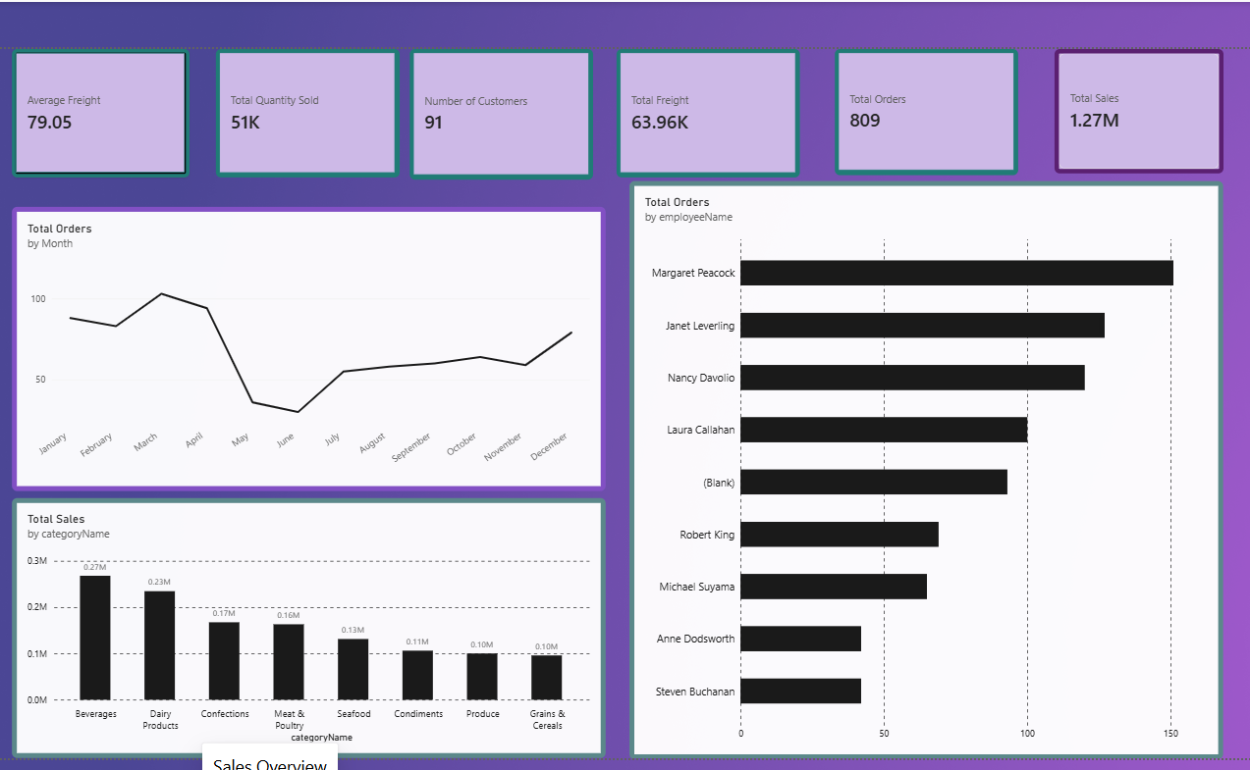
Fig 1: Sales Overview page — KPI cards, Orders by Month, Total Sales by Category, and Orders by Employee

5. Product Category Performance Analysis
The Sales by Product Category chart (categoryName vs Total Sales) shows the following distribution:
Category | Total Sales
Beverages | 0.27M
Dairy Products | 0.23M
Confections | 0.17M
Meat & Poultry | 0.16M
Seafood | 0.13M
Condiments | 0.11M
Produce | 0.10M
Grains & Cereals | 0.10M

- Highest-selling category: Beverages, with 0.27M in sales.
- Lowest-selling category: Produce and Grains & Cereals are tied at the bottom, each contributing 0.10M.
- Relative differences: Beverages outsells the lowest categories by roughly 2.7x, and even outsells the second-placed Dairy Products by about 0.04M. The drop from Confections (0.17M) to Meat & Poultry (0.16M) is small, but there is a clearer step down after the top two categories.
- Important observation: Just two categories — Beverages and Dairy Products — account for close to 40% of total category sales shown on the chart, while the bottom four categories (Seafood, Condiments, Produce, Grains & Cereals) together contribute less than the top two combined.
Key Insight
Revenue is concentrated in a small number of categories. Beverages and Dairy Products are the business's core revenue drivers, while Produce and Grains & Cereals are consistently weak performers and are candidates for promotional or assortment review.

6. Monthly Order Trend Analysis
The Orders by Month line chart plots Total Orders across January to December:
- Highest-order month: March, where the order line peaks at just above 100 orders after a small dip in February.
- Lowest-order month: June, where orders fall to their lowest point on the chart, close to 35–40 orders.
- Overall pattern: Orders start strong in Q1 (January–March), fall sharply through April and May, bottom out in June, then recover gradually and steadily from July through December, ending the year close to where it started (around 80–90 orders in December).
- Major fluctuations: The steepest change is the drop between March and June, where order volume falls by more than half. The recovery in the second half of the year is gradual rather than sharp, and December shows a modest late uptick.
Key Insight
Order volume is highly seasonal, with a strong first quarter followed by a mid-year slump (April–June) and a slow second-half recovery. This pattern is a strong candidate for targeted mid-year promotions or demand-generation campaigns.

7. Regional / Filter-Based Analysis
The Interactive Sales Dashboard page does not use a separate regional chart. Instead, it uses three slicers — Region, Category, and Year — that filter every visual and KPI on the page simultaneously (the Year slicer shows the dataset covers 2013, plus a Blank/unassigned bucket).
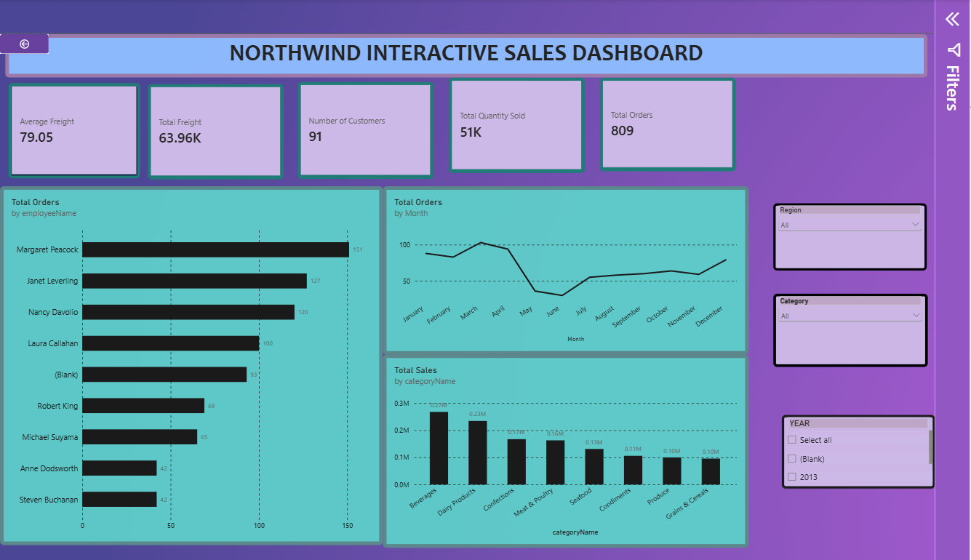
Fig 2: Interactive Sales Dashboard page — KPI cards with Region, Category, and Year slicers
To complete this section, select each region in turn on the live dashboard and record how the KPIs, category ranking, monthly trend, and employee ranking change. Suggested format:
Region | Major Observation | Business Insight
Region 1
Region 2
Region 3

- KPI changes: watch Total Sales, Total Orders, and Number of Customers shrink to that region's share of the 1.27M / 809 / 91 totals.
- Category changes: check whether Beverages and Dairy Products remain the top categories in every region, or whether a region has a different leading category.
- Monthly order changes: see whether the March peak and June dip hold in every region, or are driven mainly by one region.
- Employee performance changes: check whether Margaret Peacock stays the top performer regionally, since employees may be assigned to specific territories.
Key Insight
Because the dashboard is filter-driven rather than chart-driven, regional analysis should be done interactively: apply each Region filter, note which KPIs and rankings shift the most, and record whether any single region is responsible for the overall seasonal dip seen in Section 6.

8. Employee Performance Analysis
The Orders by Employee chart (employeeName vs Total Orders) shows:
Employee | Total Orders
Margaret Peacock | 151
Janet Leverling | 127
Nancy Davolio | 120
Laura Callahan | 100
(Blank) | 93
Robert King | 69
Michael Suyama | 65
Anne Dodsworth | 42
Steven Buchanan | 42

- Highest-performing employee: Margaret Peacock, with 151 orders.
- Lowest-performing employee: Anne Dodsworth and Steven Buchanan, tied at 42 orders each.
- Difference between employees: The gap between the highest and lowest performers is 109 orders — Margaret Peacock has handled roughly 3.6x as many orders as Steven Buchanan or Anne Dodsworth.
- Changes after applying filters: With the Region, Category, and Year slicers all set to "All," this ranking reflects full-year, all-region performance. Applying a single Region or Category filter would be expected to compress the chart and could reorder employees whose orders are concentrated in a particular territory or product line.
Key Insight
Order volume is uneven across the sales team: the top three employees (Margaret Peacock, Janet Leverling, Nancy Davolio) together handle nearly half of all recorded orders, while the bottom two handle barely a quarter of the top performer's volume. The 93 orders logged under "(Blank)" also point to a data-entry gap that should be corrected before employee performance is used for evaluation or incentives.

9. Business Insights

Insight 1 — Revenue is concentrated in two product categories
Observation: Beverages (0.27M) and Dairy Products (0.23M) together generate close to 40% of total category sales, while the bottom four categories combined contribute less.
Insight: The business is heavily reliant on two categories for revenue, which is a concentration risk if supply or demand for either category is disrupted, but also a clear opportunity to double down on what is already working.

Insight 2 — Order volume is strongly seasonal with a mid-year slump
Observation: Orders peak in March (just over 100), fall sharply to a June low (~35–40), and only gradually recover through December.
Insight: Demand is not steady through the year; the business likely needs a deliberate plan (promotions, pricing, staffing) for the April–June period rather than treating the dip as random noise.

Insight 3 — Sales performance is unevenly distributed across employees
Observation: The top three employees handle far more orders (151, 127, 120) than the bottom performers (42, 42), and 93 orders have no employee assigned.
Insight: There is room to raise overall performance by studying what the top performers do differently, and the unassigned "(Blank)" orders indicate a data quality issue that is currently limiting how reliable this analysis can be.

10. Business Recommendations
- Product category planning: Run targeted promotions, bundles, or cross-sells for Produce and Grains & Cereals to close the gap with Beverages and Dairy Products.
- Inventory planning: Align stock levels with the March peak and June trough — build up inventory ahead of Q1 and scale back ordering heading into the April–June slowdown.
- Regional strategy: Use the Region slicer regularly to identify which territories are driving (or dragging down) overall sales, and tailor strategy region by region rather than treating the market as uniform.
- Employee performance: Pair top performers such as Margaret Peacock and Janet Leverling with lower-performing employees (Anne Dodsworth, Steven Buchanan) in a mentoring arrangement, and investigate the 93 "(Blank)" orders to restore data quality.
- Monthly order planning: Introduce a mid-year campaign (April–June) — discounts, loyalty incentives, or marketing pushes — specifically to counter the seasonal dip identified in the monthly trend.
- Freight management: Monitor Total Freight (63.96K) and Average Freight (79.05) alongside order volume to spot whether shipping costs are eroding margins on lower-value categories such as Produce.
- Customer targeting: With only 91 customers driving 1.27M in sales, prioritise retention and upsell campaigns for existing high-value customers while exploring acquisition to reduce reliance on a small customer base.

11. Conclusion
Overall, the dashboard shows a business built on Northwind's classic sales data (2013) with 809 orders, 91 customers, and 1.27M in total sales across 8 product categories, 9 employees, and multiple regions, tied together through interactive Region, Category, and Year slicers.
- Overall dashboard findings: Sales are concentrated in two categories, order volume swings sharply by season, and employee performance is unevenly spread across the sales team.
- Most important business insight: The March-to-June order collapse is the single biggest pattern in the data, since it affects revenue, staffing, and inventory planning all at once.
- Key recommendation: Launch a mid-year (April–June) sales and promotion push to flatten the seasonal dip while continuing to invest in the already-strong Beverages and Dairy Products categories.
- How Power BI helped: Power BI made it possible to combine KPI cards, trend charts, category and employee comparisons, and interactive slicers into a single view — turning scattered order-level data into a small number of clear, actionable patterns that would be far harder to spot in raw spreadsheet form.

